KickStart 无人值守安装

# 简介

## PXE

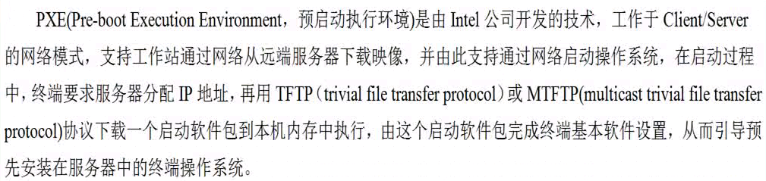

## PXE的工作过程

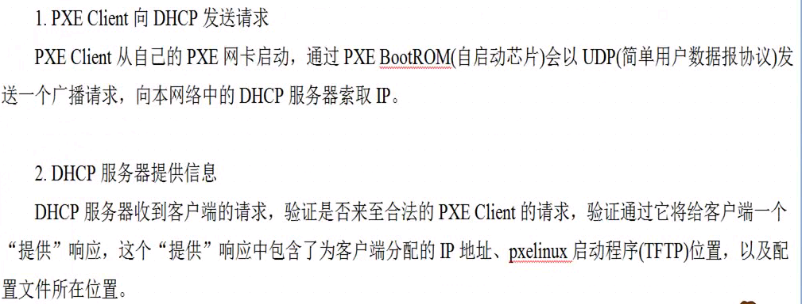

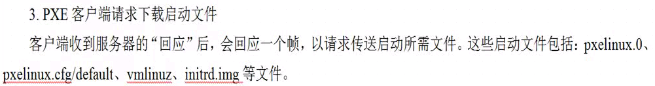

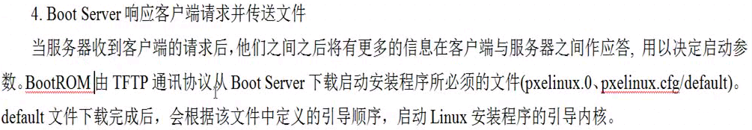

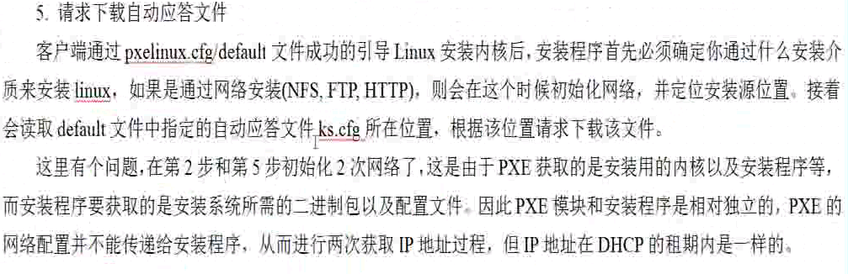

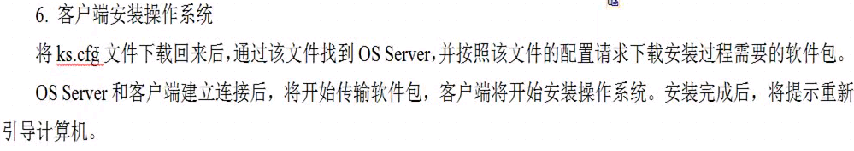

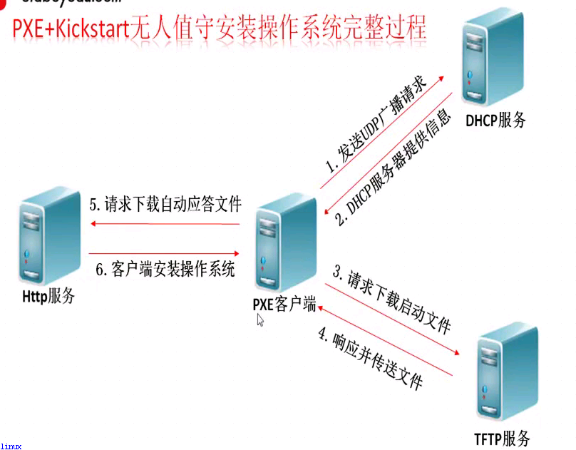

## 批量装机软件介绍

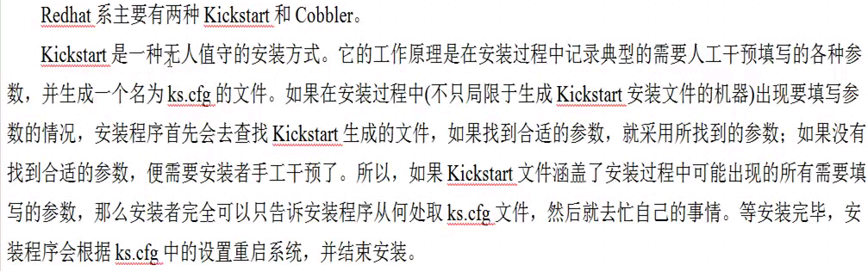

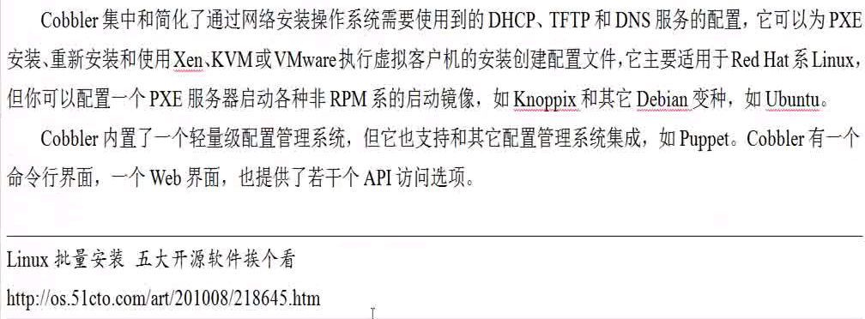

## 系统环境准备

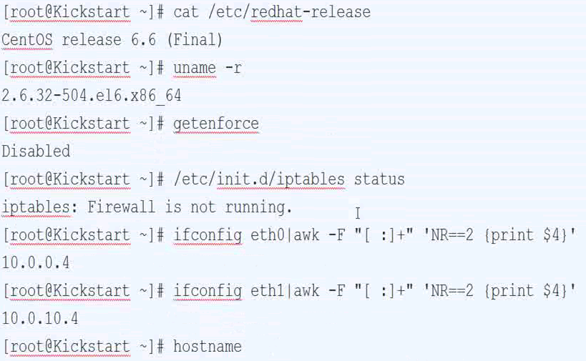

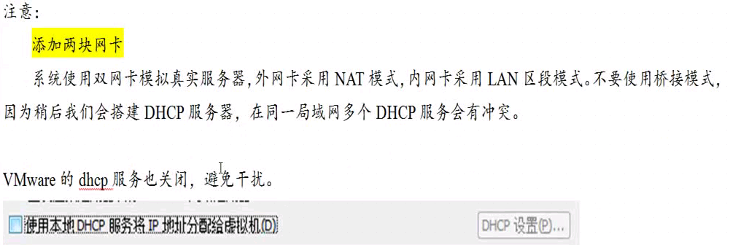

# 安装DHCP服务

## DHCP简介

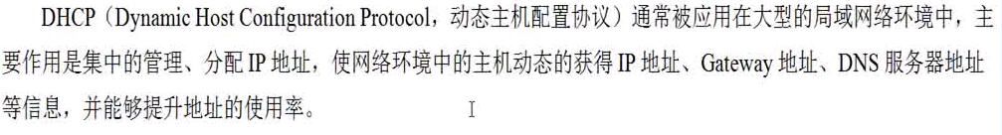

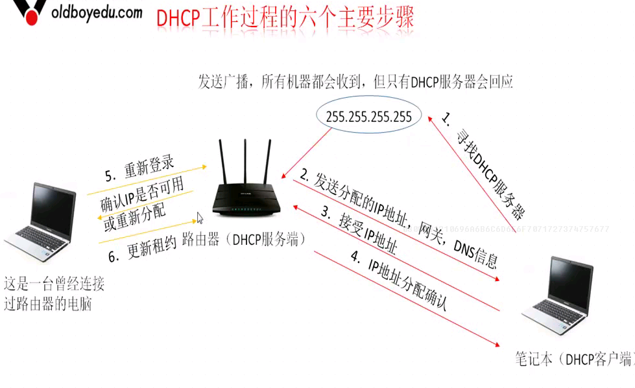

## DHCP服务安装配置

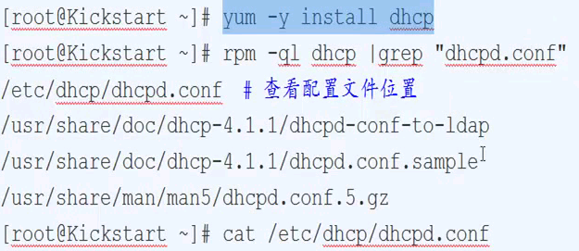

[root@kick-start yum.repos.d]# cat /etc/dhcp/dhcpd.conf

#

# DHCP Server Configuration file.

# see /usr/share/doc/dhcp*/dhcpd.conf.sample

# see 'man 5 dhcpd.conf'

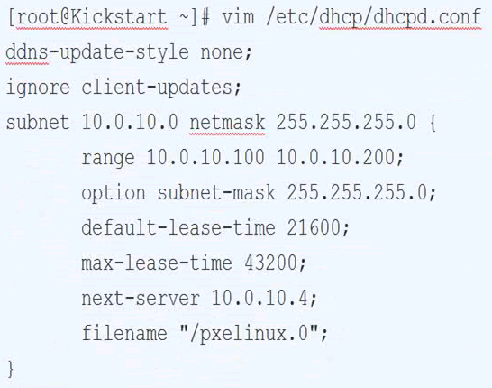

#

# DHCP Server Configuration file.

# see /usr/share/doc/dhcp*/dhcpd.conf.sample

# see 'man 5 dhcpd.conf'

#

ddns-update-style none;

ignore client-updates;

subnet 172.16.1.0 netmask 255.255.255.0 {

range 172.16.1.101 172.16.1.200;

option broadcast-address 172.16.1.255;

option subnet-mask 255.255.255.0;

default-lease-time 21600;

max-lease-time 432000;

next-server 172.16.1.100;

filename "/pxelinux.0";

}

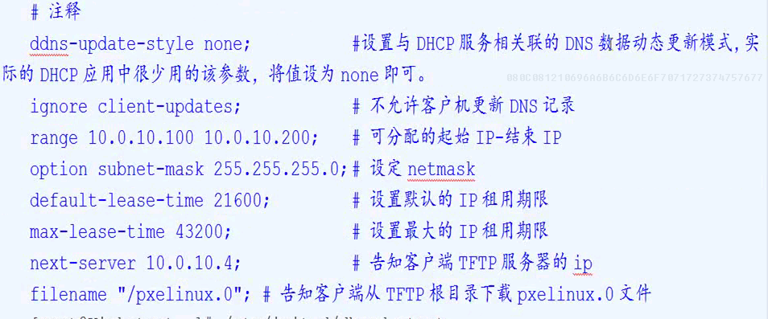

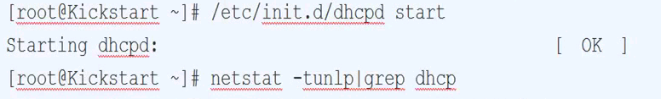



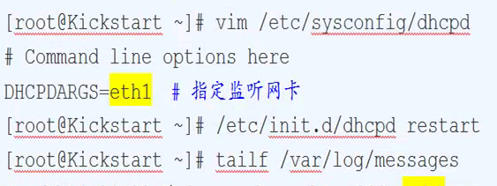

# 安装TFTP服务

## 简介

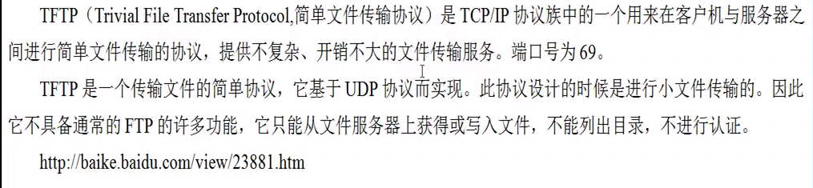

## 安装配置

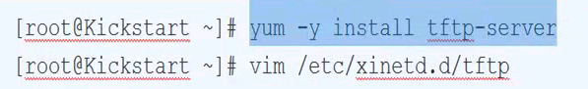

# default: off

# description: The tftp server serves files using the trivial file transfer \

# protocol. The tftp protocol is often used to boot diskless \

# workstations, download configuration files to network-aware printers, \

# and to start the installation process for some operating systems.

service tftp

{

socket_type = dgram

protocol = udp

wait = yes

user = root

server = /usr/sbin/in.tftpd

server_args = -s /var/lib/tftpboot

disable = no

per_source = 11

cps = 100 2

flags = IPv4

}

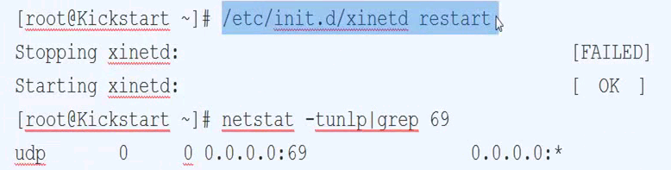

# HTTP服务

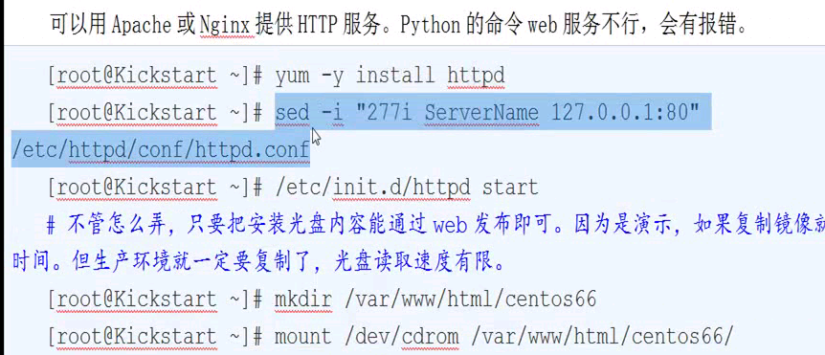

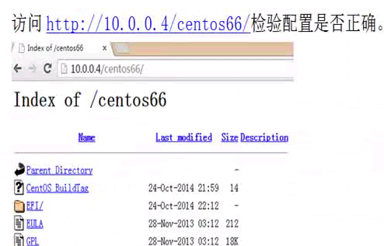

# 配置支持PXE的启动程序

## PXE引导配置

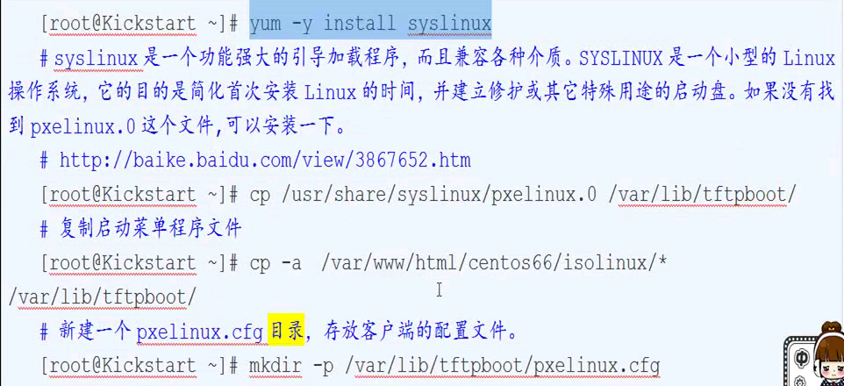



[root@kick-start yum.repos.d]# cp /usr/share/syslinux/pxelinux.0 /var/lib/tftpboot/

[root@kick-start yum.repos.d]# cp -a /var/www/html/centos66/isolinux/* /var/lib/tftpboot/

## PXE配置文件解析



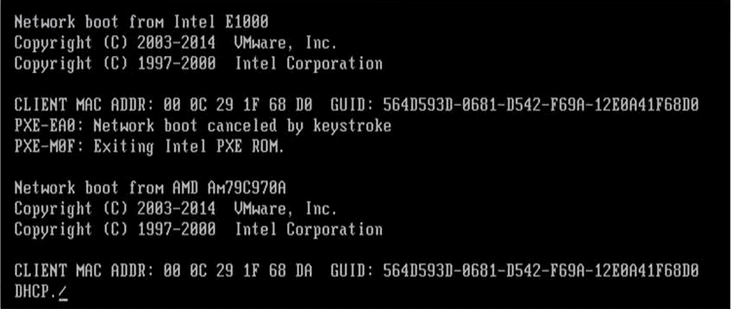

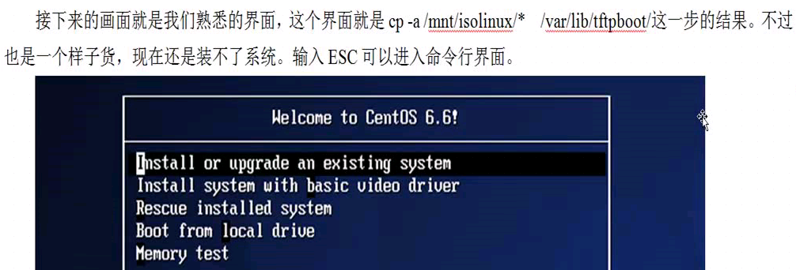

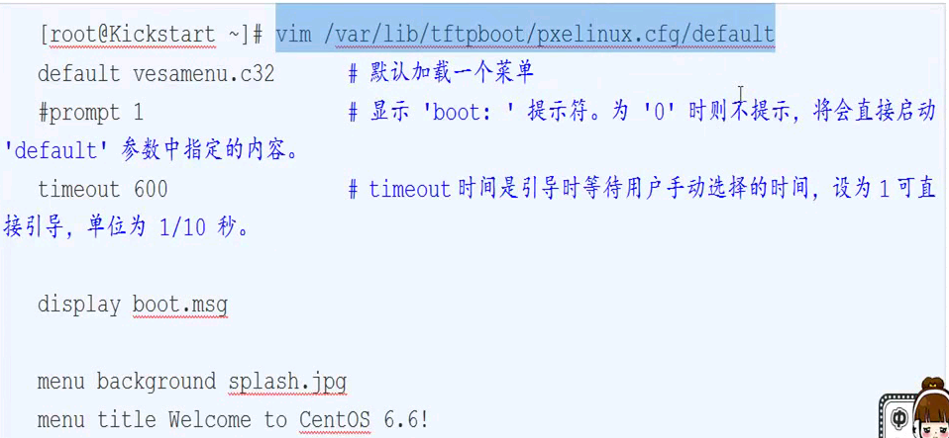

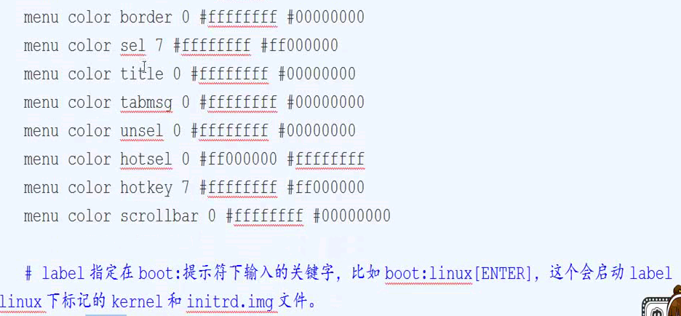

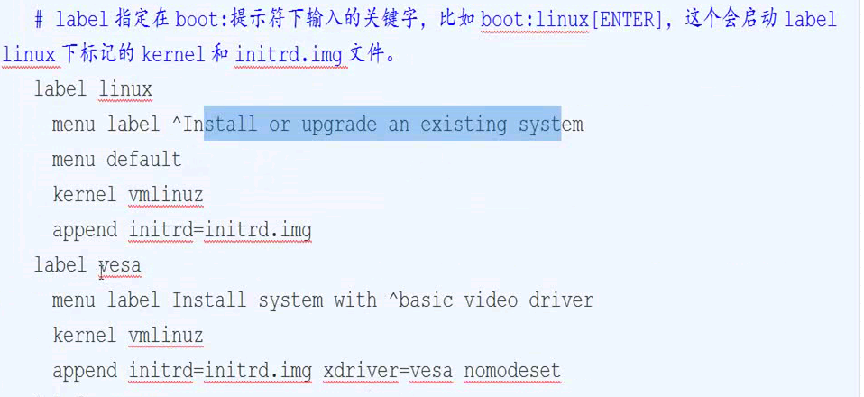

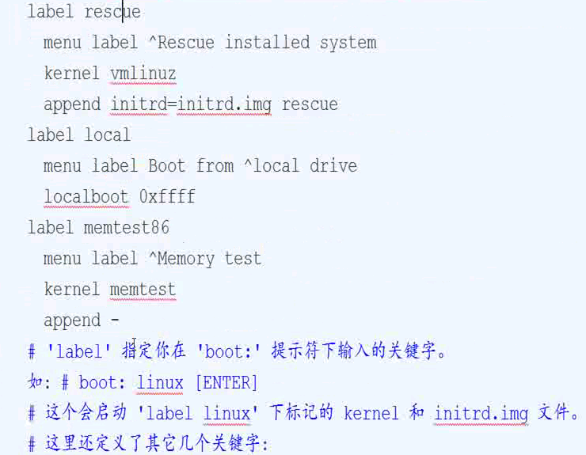

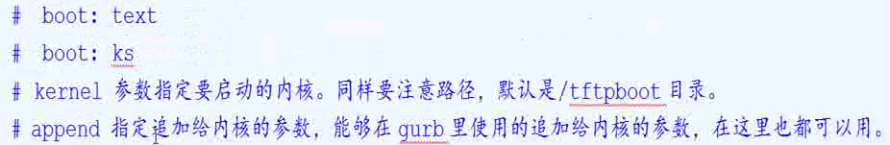

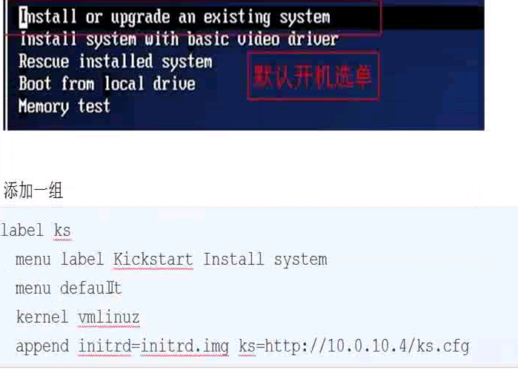

## 最简配置—自动化安装

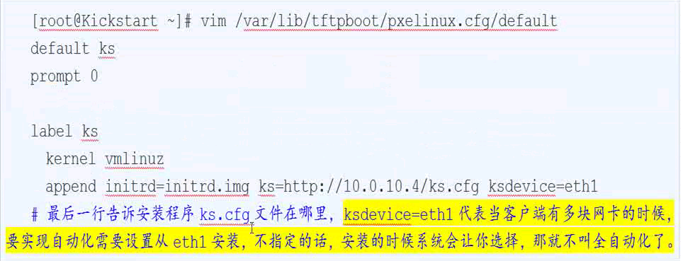

## 配置文件扩展知识

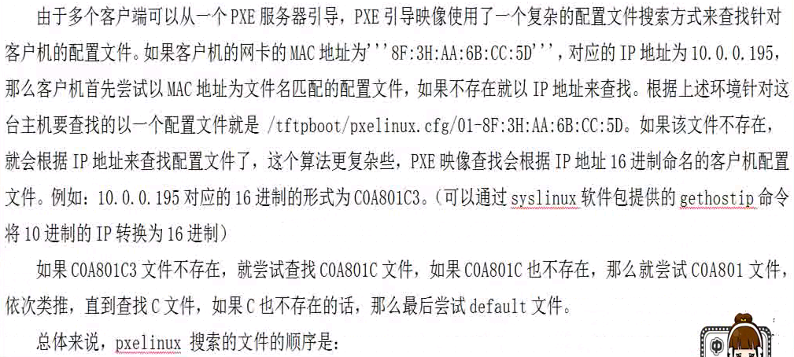

# 预热手动网络安装

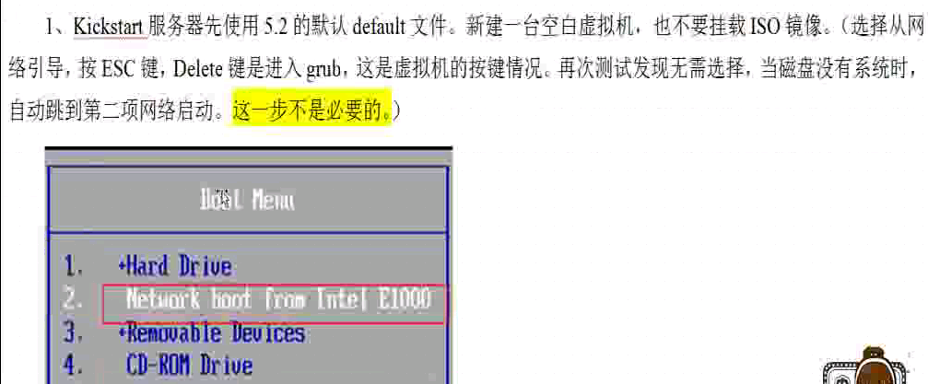

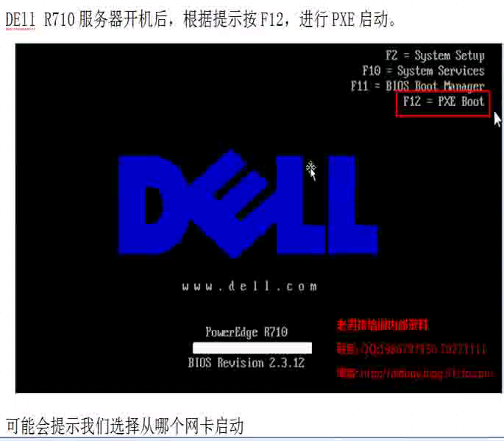

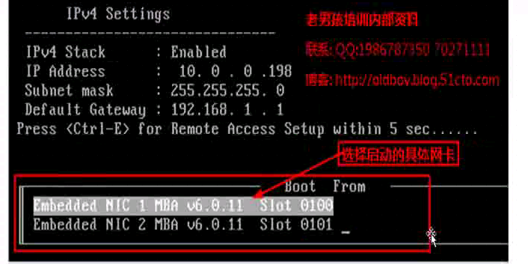

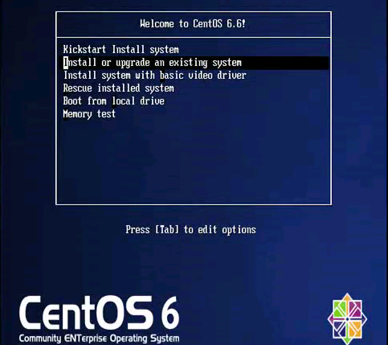

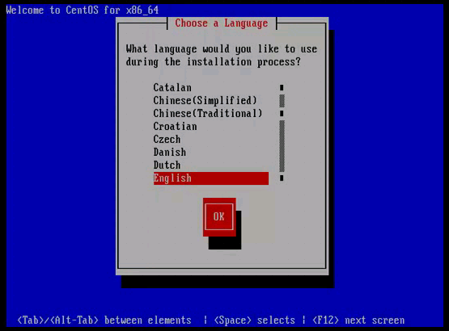

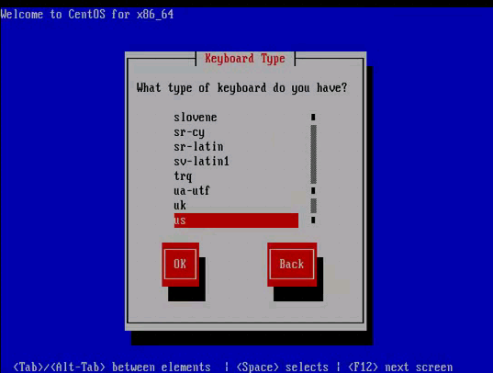

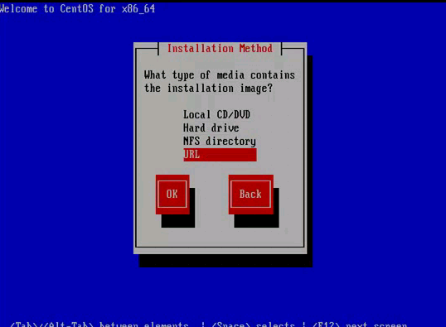

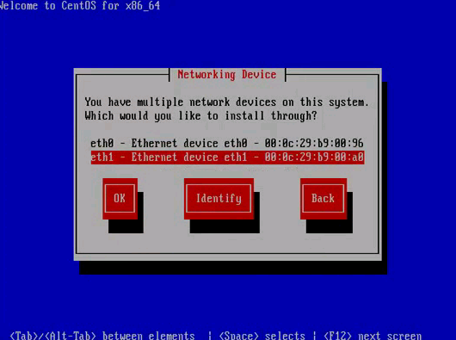

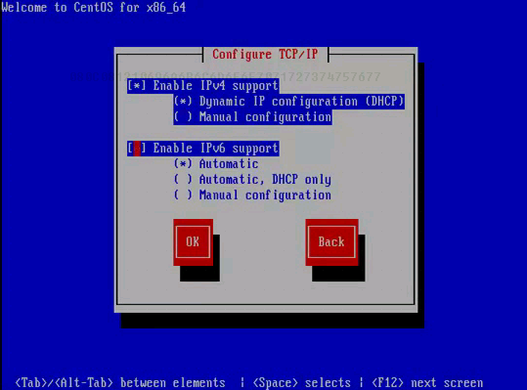

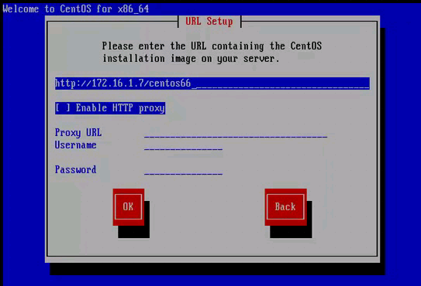

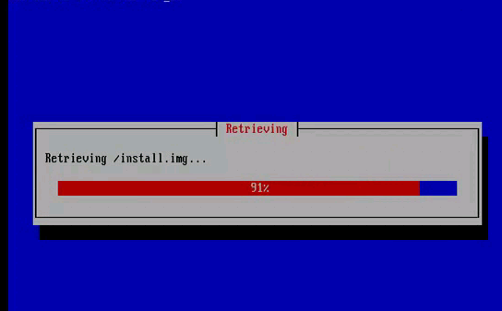

# 创建KS文件

## 简单介绍

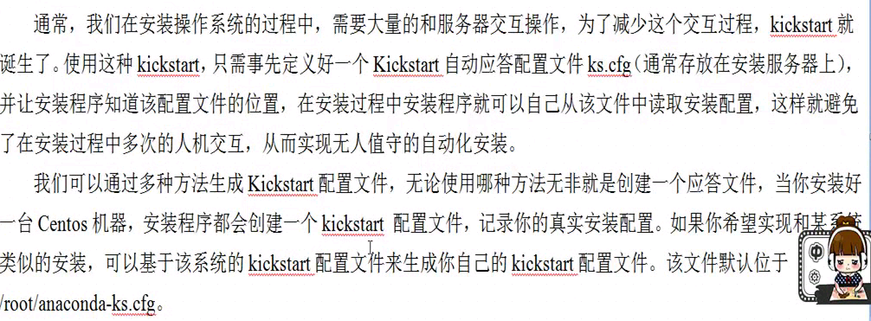

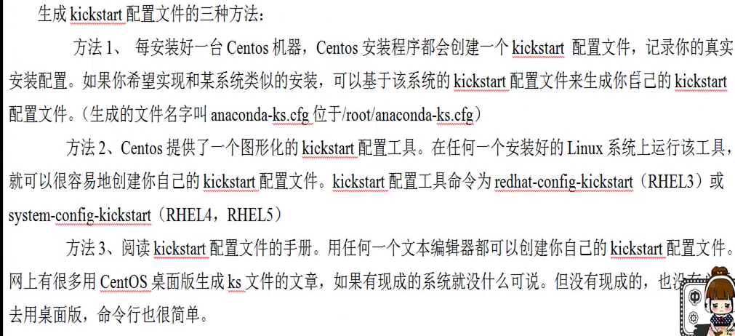

## KS文件详解

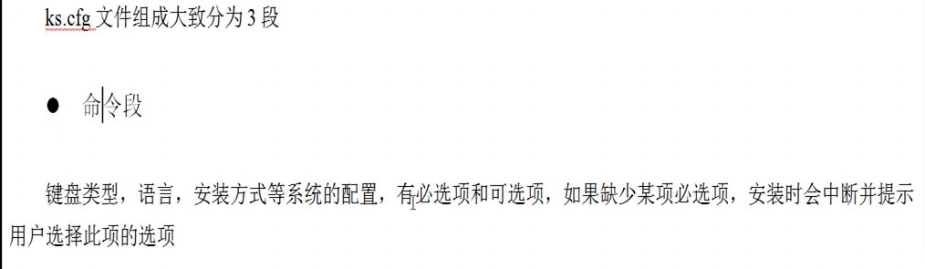

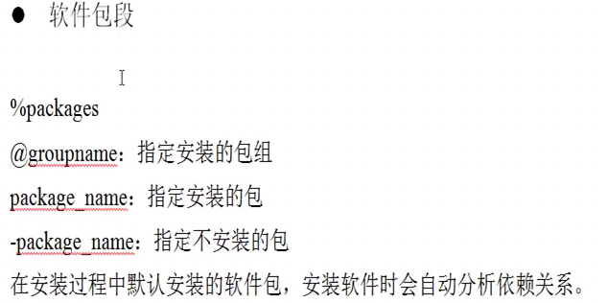

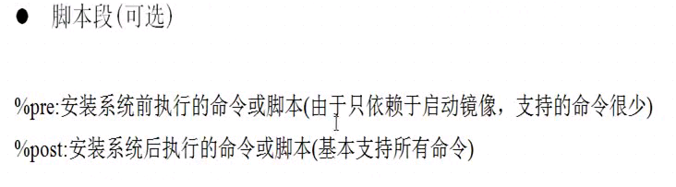

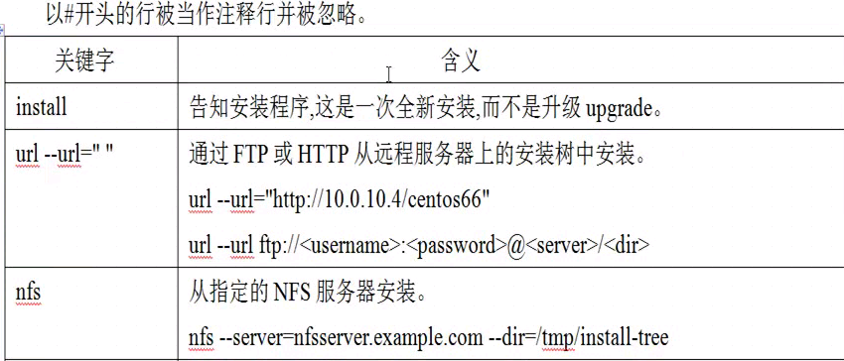

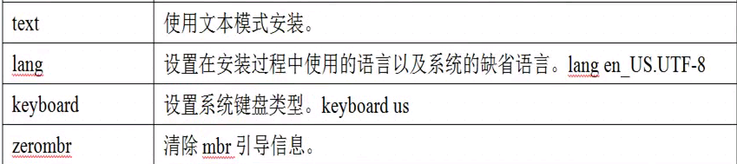

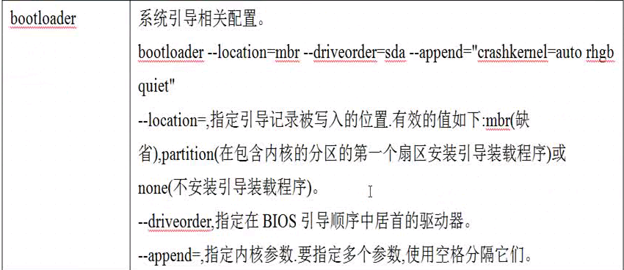

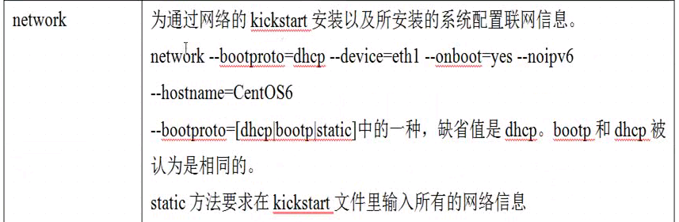

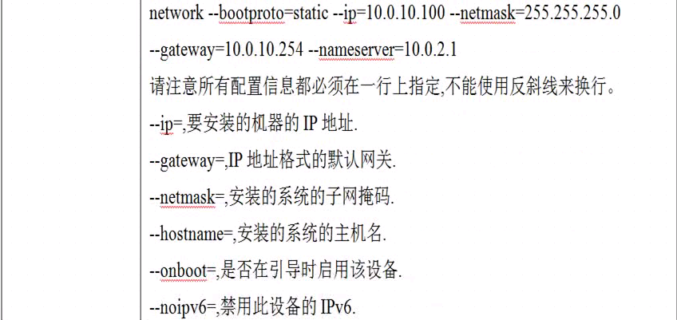

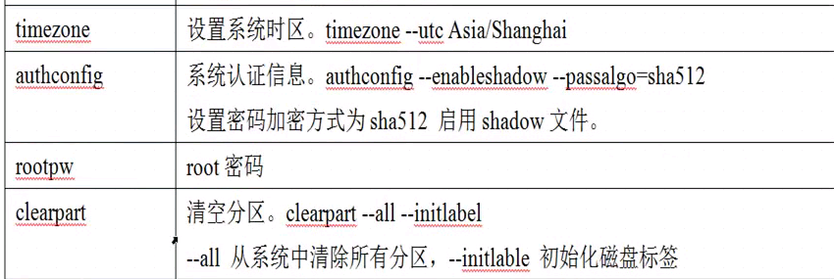

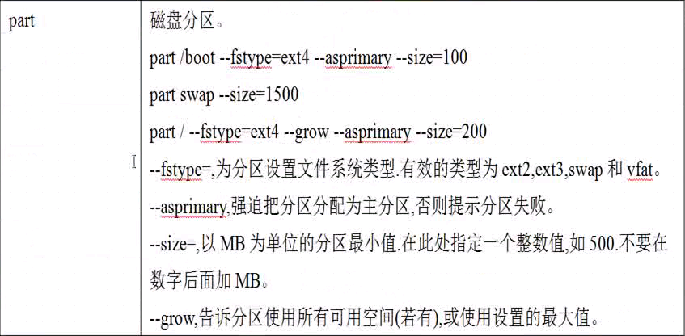

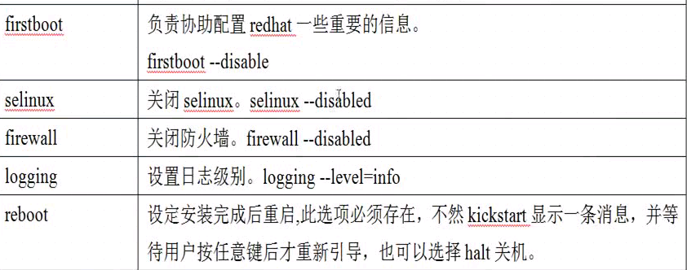

## 准备文件

